Xavier Joaquinho

**Electricity Generation**

Electricity it is a form of energy which is generated through the flow of charged particles, such as electrons, from a high voltage point to a low voltage point in a conductor. A conductor is a material, a substance, or an element with free electrons in its atomic structure, such as copper. These free electrons move freely from one point to another, within or on the surface of the conductor, when these points are at a different potential. That is, when these points of the conductor are at a different value of voltage. Voltage is a force that influences the flow of electrons on or in a conductor, and it’s called an electromotive force. Electricity has a wide range of usage. It’s used for lighting, heating, or cooling houses or buildings, also for refrigeration, for operation of devices such as appliances, computers, cellphones, and for operation of machinery among others. There are different ways of generating electricity. It can be generated through coal, oil, gas, water, wind and sun. Despite of different ways of production of electricity, each form of production presents advantages and disadvantages. This paper focuses on the production of electricity through water and wind. It talks about the process involved in for the production of electricity. It also touches on advantages and disadvantages in producing electricity through water and wind, the cost involved for humans and attempts to suggest which one is better than the other between these two forms of production.

Water is one of the natural resources that has a multiple applications. We use water for a variety of things, such as cooking, drinking, showering, irrigating farm fields, washing, production of resources such as electricity,cooling electricity plants and among other applications. Generation of electricity through water requires power plant, such as Hydroelectric power plant. Basically, Hydroelectric power plant uses a falling water to convert the energy generated in that process into electrical power by passing it through turbines. A turbine is a mechanical machine that produces a  continuous power in which a wheel or rotor, fitted with vanes, is made to revolve by a fast-moving flow of liquids, such as water, steam, gas, and air.

The process of producing electricity through water involves construction of a dam at the site of production. A dam  is built usually on a large river with a large drop in elevation[1]. The dam is used to store lots of water behind it, and the storage is called reservoir[1]. Near the bottom of the dam wall a water intake is positioned to allow the water to reach turbines[1]. There is presence of gravitational force at the elevation of the water drop, which causes it to fall through a material called penstock inside the dam[1]. At the end of this material there is a turbine propeller and this is turned to rotate by the moving water through it. This rotation generates mechanical energy which is taken  into a generator. The generator, then,  converts it into electrical power[1]. This power is then transported through power lines to our homes, companies, stores and other locations[1].

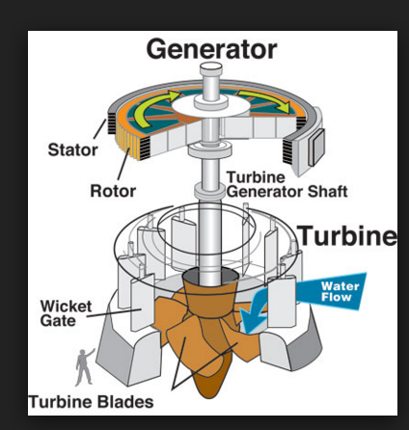

Fig 2. [8]Hydropower turbine

The construction of dams involves huge some of money. However, the cost varies depending on factors, such as the amount of power to be produced, the level of water for intake and outflow, turbine types among others [2]. For example, the amount of power generated can vary from as low as 5kW to as high as 500kW [2][3]. The less the amount of power to be produced, the lower will be the cost associated with the construction of the dam. Likewise, the more the amount of power to be produced, the greater is the cost associated with the construction of the dam. This can be evidenced from the table below. Looking at the first two columns from left, it’s clear that the more or the less the power produced the higher or the lower is the cost involved in the construction of a dam.

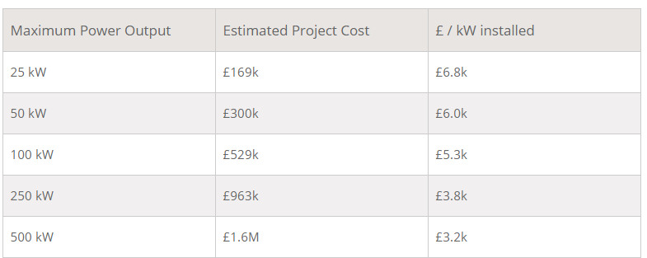

Table 1. Shows estimated project cost in pounds  for dams and their maximum power output[2].

Production of electricity through any means has advantages as well as disadvantages. There are lots of advantages as well as disadvantages associated with production of electricity through water. The reservoirs created for the production of electricity can be used for a variety of recreational activities, such as fishing, swimming just to mention a couple[4]. The water stored in the reservoirs can also be used to control flooding as well as to supply to the community around or even beyond by extending a lot of water tubes to be used for drinking or irrigation of farm fields[4]. Also, producing power through water is renewable. The water used from the reservoirs to produce power can be flown back into the reservoirs, if the river connects. Also, water in the rivers depend on water cycle driven by the sun[4]. This means, if the level of water of the rivers falls it will always be pulled back as long as it rains. This, however, will depend on the amount of the rain itself. More rain will likely bring back the waters to their previous level or even beyond.

Despite of the above, the creation of reservoirs can have a harming impact. It can prevent fish from moving or migrating to a different location beyond the reservoir itself. That is fish populations can be impacted if fish cannot migrate upstream past impoundment  dams to spawning grounds or if they cannot migrate downstream to the ocean[4]. Also, the quality of water as well as its flow can be impacted by the reservoirs as the wall created for establishment of reservoirs blocks the water from moving.  As mentioned above electricity from water depends on the water cycle driven by sun, if there is no rain for a long period of time, like couple years or even a year, there will be drought and this will inevitably affected the production of power negatively. This will lead to either low level of power production or no power at all. Furthermore, the blocking of river waters from flowing can lead to flooding on the nearby lands. hydropower facilities impact the local environment and may compete with other  uses for the land[4]. Those alternative uses may be more highly valued than electricity generation[4]. Humans, flora, and fauna may lose their natural habitat[4]. There are many more disadvantages associated with production of electricity through water.

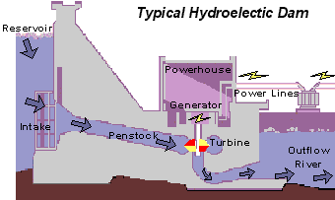

Fig 1. Is pictorial process on the production of electricity through Hydroelectric plant[1].

Wind, just like water, is also a natural resource. And it may be defined as a natural flow or movement of the air. It helps humans with their respiration[5]. It also helps in the development of plants, trees, crops  among other things[6]. Apart from the above, it is used for production of electricity just like water. Like hydropower, wind power is also generated by turbines. However, these turbines are different from the ones used in hydropower and they are called wind turbines.

The production of power through wind is done through a simple process. Wind turbines are positioned in places where there is a strong presence of wind. The turbines rotate when wind blows on them. This rotation makes turbines to convert the kinetic energy in the wind into a mechanical energy[7]. A generator is then used to convert this mechanical energy into electrical energy, which is then used to power homes, businesses, schools among other things.

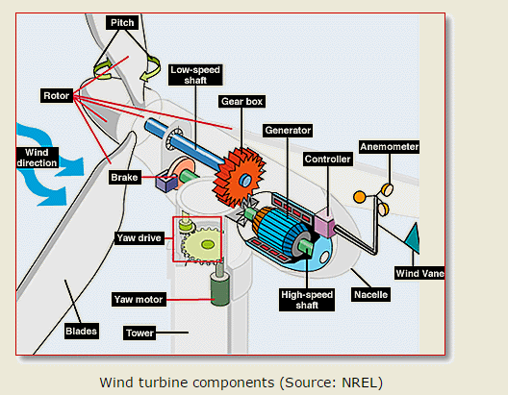

Fig 3.[7] Wind Turbine

Just like hydropower, the cost of generating power through wind depends on the amount of power to be produced. However, the amount of power depends on the rotor diameter of the turbine and on the speed through which the turbines rotate[10]. The more the power to be produced, the higher will be the cost. Likewise, the less the power to be produced the lower will be the cost. This can be see in the second table below.

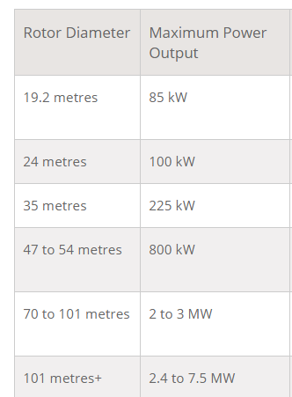

Table 2.[10] shows the rotor diameter of a turbine  and the maximum output power

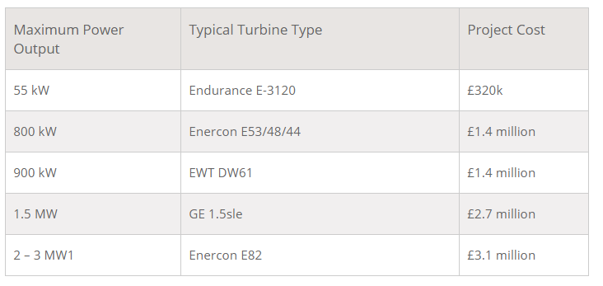

Table 3.[11] maximum power output from wind turbines and project cost.

Wind power, just like hydropower, has numerous advantages as well as disadvantages. Among other benefits from wind power, the towers holding the turbines do not take up much space[12]. This means a lot of space around them can still be used for other things, such as agriculture. The turbines can be placed anywhere in a country, as they only rely on wind. This means , remote areas, wind turbines can be used as great resource to generate energy[12]. Also,  in combination with Solar Energy they can be used to provide reliable as well as steady supply of electricity[12]. Despite of the benefits above, wind power pose a threat to wildlife as the turbines blades are in the open air[12]. This means, if the blades loosen up and fall down they can cause serious damage, i.e it can either destroy, wound or kill whatsoever it might hit. There is fluctuation in the flow or blowing of wind. That means winds are uncertain and unpredictable [12].This can likely affect the production of electricity. It is possible that production stops at all, if the wind fails to rotate the turbines blades. Otherwise, there can be a very little supply of electricity causing some of the homes or businesses to be out of power. Furthermore, wind power can be harnessed only in those areas where wind is strong enough and weather is windy for most parts of the year.

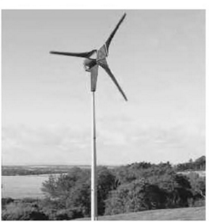

Fig 4.[9] pictorial representation of wind power production.

The production of electricity is based on natural resources, as mentioned in the introduction. However, some of these resources are renewable and other non-renewable. Renewable sources are water,wind, and solar. Non-renewable sources are gas, and coal. Moreover, some of these sources, such as coal and gas, pose threat to life. They emit greenhouse gases, which lead to global warming. In regards to the paper, the cost of producing power through wind does not differ that much from the cost of producing it through water. However, the cost of producing power through wind has been declining for the past couple years. Both wind power production as well as hydropower production have advantages and disadvantages. Comparing the advantages and disadvantages of both sources of production of electricity and considering the decline in the cost of producing power through wind , one is likely to say that wind power is better than hydroelectric power so long as wind power is coupled with solar power to make it more reliable and steady. It would be easier to power a full nation with wind power than with Hydroelectric power, as wind turbines can be placed anywhere as long as the place is not uncomfortable for the population in the surroundings and its coupled with solar energy.

Work Cited

[1]<http://water.usgs.gov/edu/hyhowworks.html>

[2][www.renewablesfirst.co.uk/hydropower/hydropower-learning-centre/how-much-do-hydropower-systems-cost-to-build/](http://www.renewablesfirst.co.uk/hydropower/hydropower-learning-centre/how-much-do-hydropower-systems-cost-to-build/)

[3]<http://www.irena.org/documentdownloads/publications/re_technologies_cost_analysis-hydropower.pdf>

[4]<http://www.envirothonpa.org/documents/19bHydropowerAdvantagesandDisadvantages.pdf>

[5]<http://www.nhlbi.nih.gov/health/health-topics/topics/hlw/system>

[6]<http://agriinfo.in/?page=topic&superid=1&topicid=404>

[7]<http://windeis.anl.gov/guide/basics/>

[8]<https://www.google.com/search?q=hydropower+turbine&espv=2&biw=929&bih=931&tbm=isch&imgil=i4DVb4ug368L4M%253A%253BYuzqxxpvFj-FeM%253Bhttp%25253A%25252F%25252Fwater.usgs.gov%25252Fedu%25252Fhyhowworks.html&source=iu&pf=m&fir=i4DVb4ug368L4M%253A%252CYuzqxxpvFj-FeM%252C_&usg=__Ci51H8C-FA6XZMAsooq0GpAPjHs%3D&ved=0ahUKEwiJooXN_unLAhXBSiYKHet7ADEQyjcILw&ei=UJr8Vom6CMGVmQHr94GIAw#imgrc=i4DVb4ug368L4M%3A>

[9]<https://books.google.com/books?id=kY1-ciIQd9UC&pg=PA99&lpg=PA99&dq=pictorial+representation+of+wind+power+production&source=bl&ots=0ibXFT8RnO&sig=Y2bsHJZwEZlql8mlFw7FoVJZ0Fg&hl=en&sa=X&ved=0ahUKEwifnqS5gOrLAhUB4CYKHRIUB30Q6AEIPDAG#v=onepage&q=pictorial%20representation%20of%20wind%20power%20production&f=false>

[10]//[www.renewablesfirst.co.uk/windpower/windpower-learning-centre/much-power-generate-wind-turbine/](http://www.renewablesfirst.co.uk/windpower/windpower-learning-centre/much-power-generate-wind-turbine/)

[11]<https://www.renewablesfirst.co.uk/windpower/windpower-learning-centre/how-much-does-a-farm-wind-turbine-small-wind-farm-turbine-cost/>

[12]<http://www.ianswer4u.com/2012/02/wind-energy-advantages-and.html#axzz44SGryl4d>